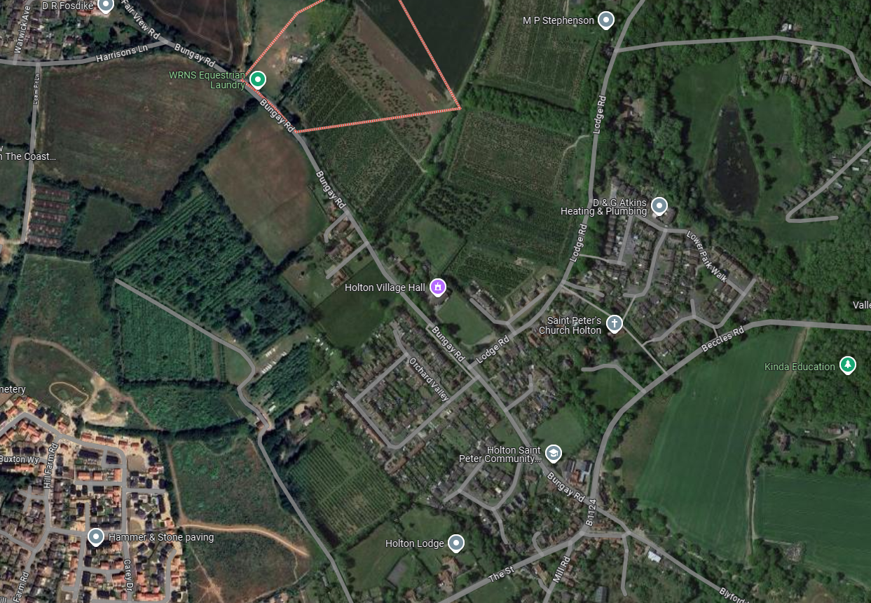

Site Boundary

Access Point to Field

Section of Road Blocked

Borehole Drilling Location

Extents of Formal Road Closure (access still possible to all properties)